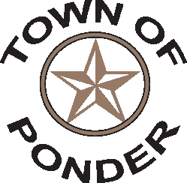
PUBLIC WORKS MAINTENANCE TECH

Position Overview
Under supervision of the Public Works Director. Responsible for general maintenance on Town facilities and equipment and sites.
Essential Job Functions
Perform general maintenance of Town facilities and Town equipment.
Assist in maintaining roadways within the Town.
Mow, edge and keep in good and safe condition the Town’s property.
Execute such other duties as Director of Public Works, the Mayor and Town Council require.
Town janitorial duties.

Requirements
High School Diploma or equivalent
Valid Texas driver’s license

Experience, Training, Knowledge and Skills
Basic knowledge of equipment used in maintaining Town property and facilities.

Physical Demands and Working Conditions
Physical requirements include lifting a minimum of 50 lbs., able to tolerate all weather conditions.

NOTE: This job description is not intended to be all-inclusive. Employee may perform other related duties as negotiated to meet the ongoing needs of the organization.

